**Assignment: 5**

**Experiments**

1. **Write a Python program to use try-except-else block.**

**Coding:**

print("Try and except-else block for solving a exception:")  
try:  
 print("Statement Is")  
 num1= int(input("enter a 1st number: "))  
 num2 = int(input("enter a 2nd number: "))  
 print(num1/num2)  
except ZeroDivisionError:  
 print("Don't Divide by Zero")  
except:  
 print("Please check your input number:")  
else:  
 print("This is the else bock of the program:")

**Output:**

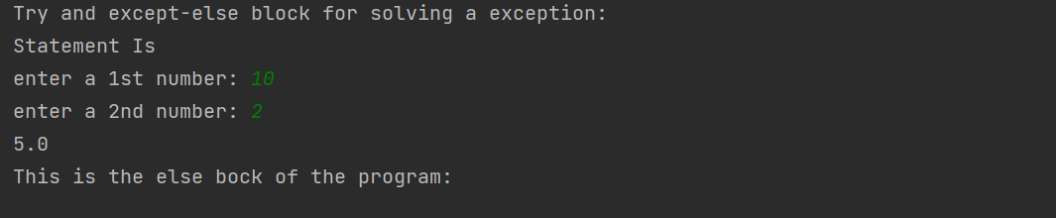

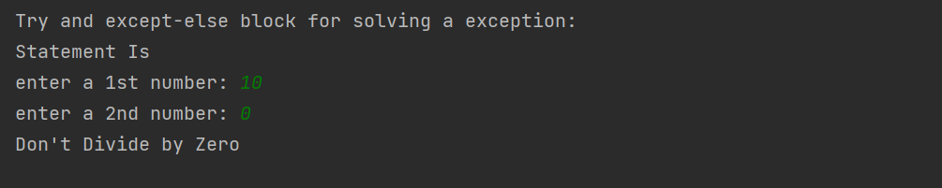

1. **Write a Python program to use try-except-finally block.**

**Coding:**

try:  
 num1= int(input("enter a 1st number: "))  
 str= str(input("enter a 2nd number: "))  
except ZeroDivisionError:  
 print("Don't Divide by Zero")  
except NameError:  
 print("Don't Divide by Name")  
finally:  
 print("This is our final block!")

**Output:**

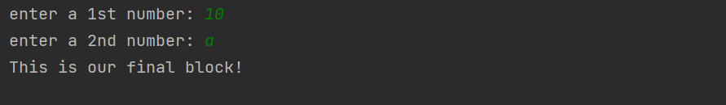

1. **Write a Python program to write your own exception and throw it.**

**Coding:**

try:  
 x=int(input("Enter the 1st number:"))  
 y=int(input("Enter the 2nd number:"))  
 print(x/y)  
except (ZeroDivisionError,ValueError) as msg:  
 print(msg)  
finally:  
 print("This is final block of the program!")

**Output:**

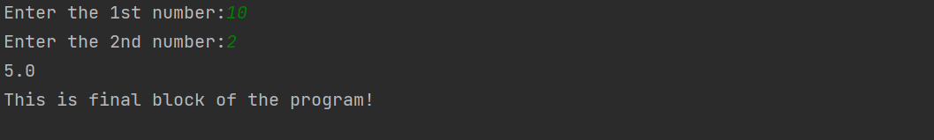

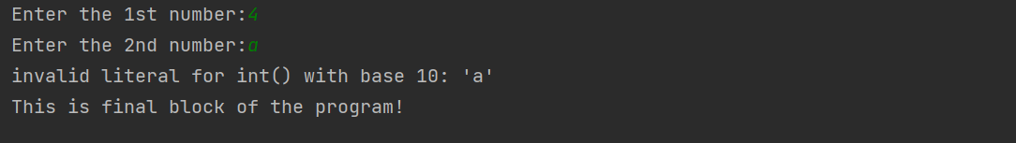

1. **Write a Python program to demonstrate the use of built-in modules random and math.**

**Coding:**

import random as r  
print("The randint() function it wil gives the between of both:",r.randint(1,8))  
li=["car","cycle","bike"]  
print(r.choices(li,weights=[5,1,1],k=10))  
import math as m  
print(m.sin(90))  
print(m.sqrt(8))  
print(m.tan(45))

**Output:**

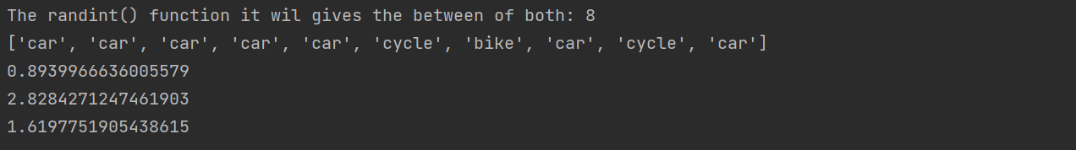

1. **Write a program to create a module and to use its functionality.**

**Coding:**

import math as m  
print("Value of pi = ", m.pi)  
a = m.ceil(11)  
b = m.floor(15)  
print("Value of ceil = ",a)  
print("Value of floor = ",b)  
print("Reminder of the numbers is: ")  
print (m.remainder(1, 10))  
print (m.remainder(15, 4))  
print (m.remainder(21, 5))  
print("Square root of the number is:")  
print (m.sqrt(49))  
print(m.sqrt(16))

**Output:**

